St. Francis Institute of Technology, Mumbai-400 103

**Department Of Information Technology**

A.Y. 2024-2025

Class: TE-ITA/B, Semester: V

Subject: **DevOps Lab**

**Experiment – 3: To Perform various GIT operations on local and Remote repositories using GIT Cheat-Sheet**

1. **Aim:** To understand version control using Git and create a GitHub account
2. **Objectives:** Aim of this experiment is that, the students will be able

* To be aware of different Version Control tools like GIT and GitHub
* To obtain complete knowledge of the “version control system” to effectively track changes augmented with Git and GitHub

1. **Outcomes:** After study of this experiment, the students will be able to

* Create and fork repositories in GitHub
* Apply branching, merging and rebasing concepts.
* Implement different Git workflow strategies in real-time scenarios
* Understand Git operations in IDE

1. **Prerequisite:** Knowledge of software engineering concept of version control
2. **Requirements:** Git,Personal Computer, Windows operating system, browser, Internet Connection, Microsoft Word.
3. **Pre-Experiment Exercise:**

**Brief Theory:** Refer shared material

1. **Laboratory Exercise**
   * + 1. **Procedure:**

**a. Answer the following:**

* Give differences between Git and GitHub
* What is Git Cheat sheet?
* Attach sample Git Cheat sheet

**b**. **Execute following on Git and GitHub (Refer the shared material) and attach screenshots:**

* Create a repository in GitHub
* Create a branch on repository
* Fork, push and Pull request
* Fetch and merge on Git

1. **Post-Experiments Exercise**
2. **Extended Theory:**

Nil

1. **Questions:**

* What are the different Git workflow strategies in real-time scenarios?
* What are the different Git IDEs available?

1. **Conclusion:**

* Write what was performed in the experiment.
* Write the significance of the topic studied in the experiment.

1. **References:**

[**https://github.com/**](https://github.com/)

[**https://guides.github.com/activities/hello-world/**](https://guides.github.com/activities/hello-world/)

[**https://git-scm.com/docs/gittutorial**](https://git-scm.com/docs/gittutorial)

**EXERCISE:**

**Execute following on Git and GitHub (Refer the shared material) and attach screenshots:**

**Making a repository on GitHub**

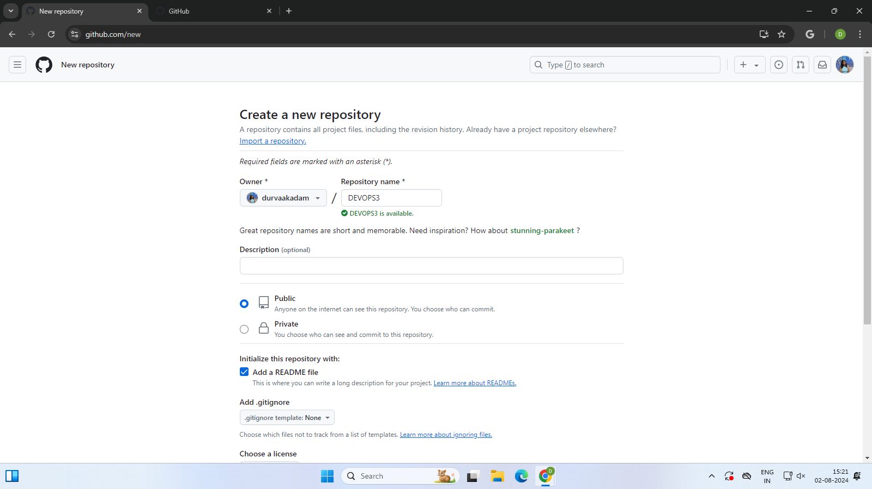

**Creating a branch in repository.**

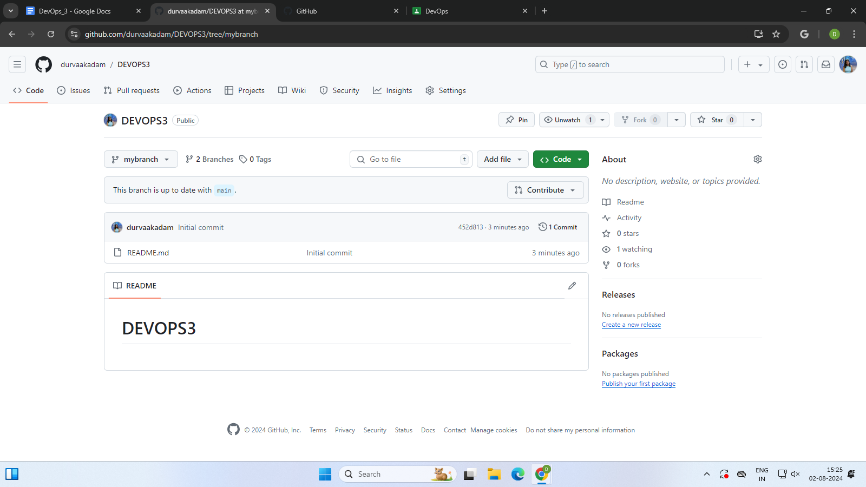

**Forking a repository.**

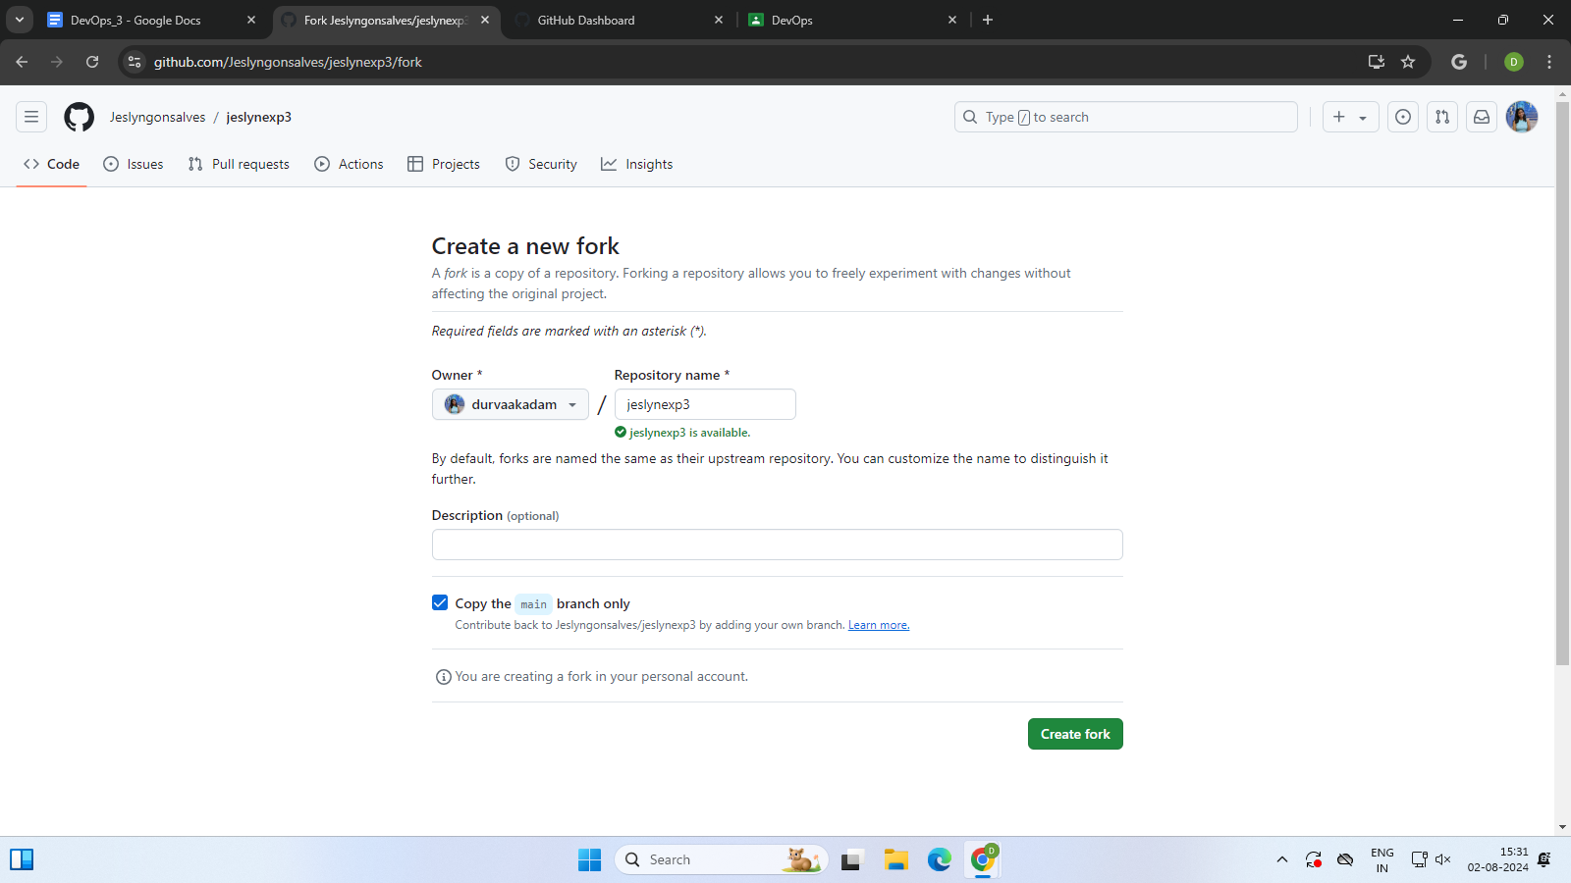

**Deleting the forked repository.**

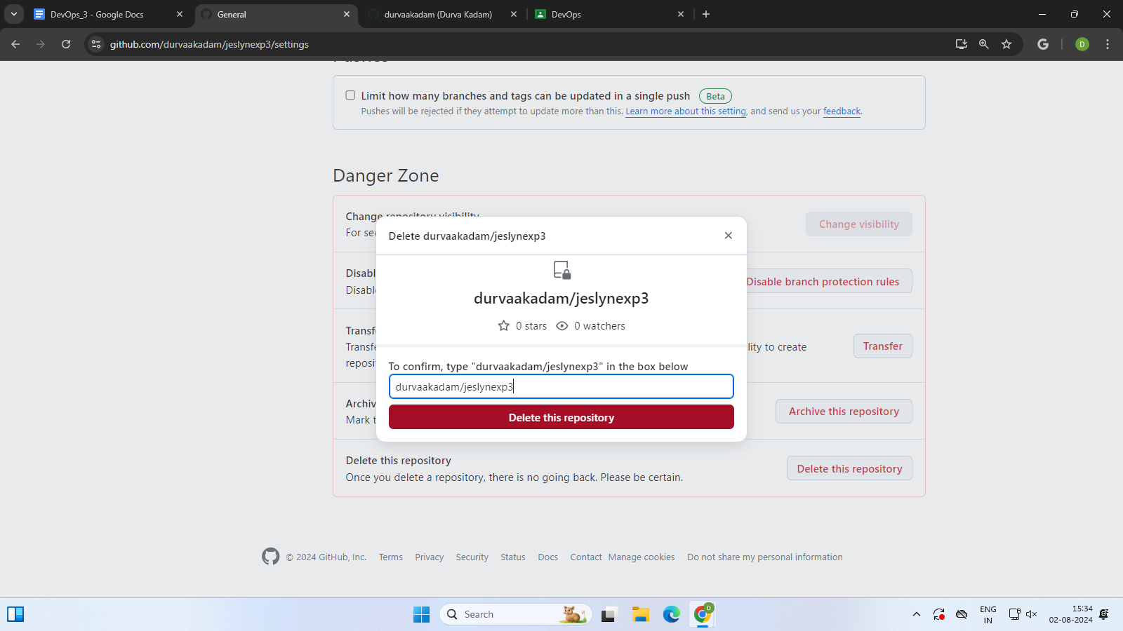

**CLONING AN EXISTING REPOSITORY.**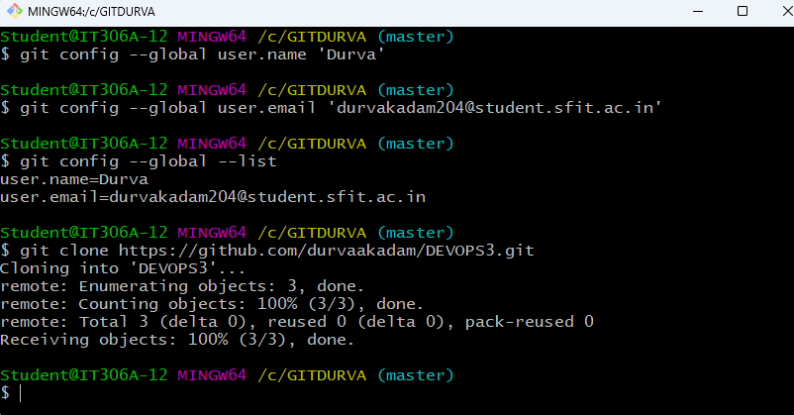

**CLONED THE REPOSITORY SUCCESSFULLY.**

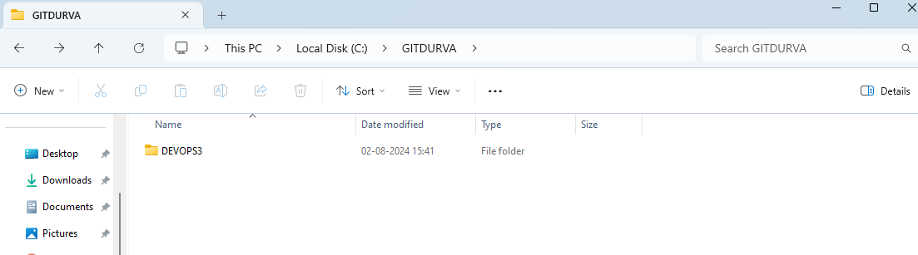

**ADDING A REMOTE REPOSITORY:**

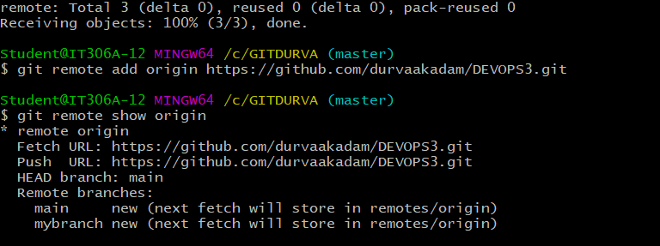

**SUCCESSFUL AUTHENTICATION:**

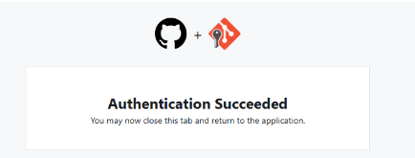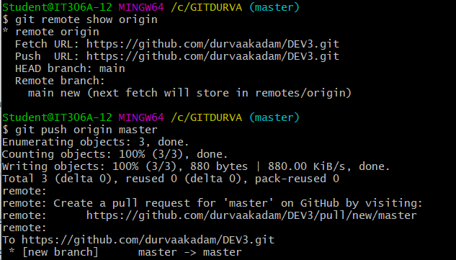

**GIT PUSH:**

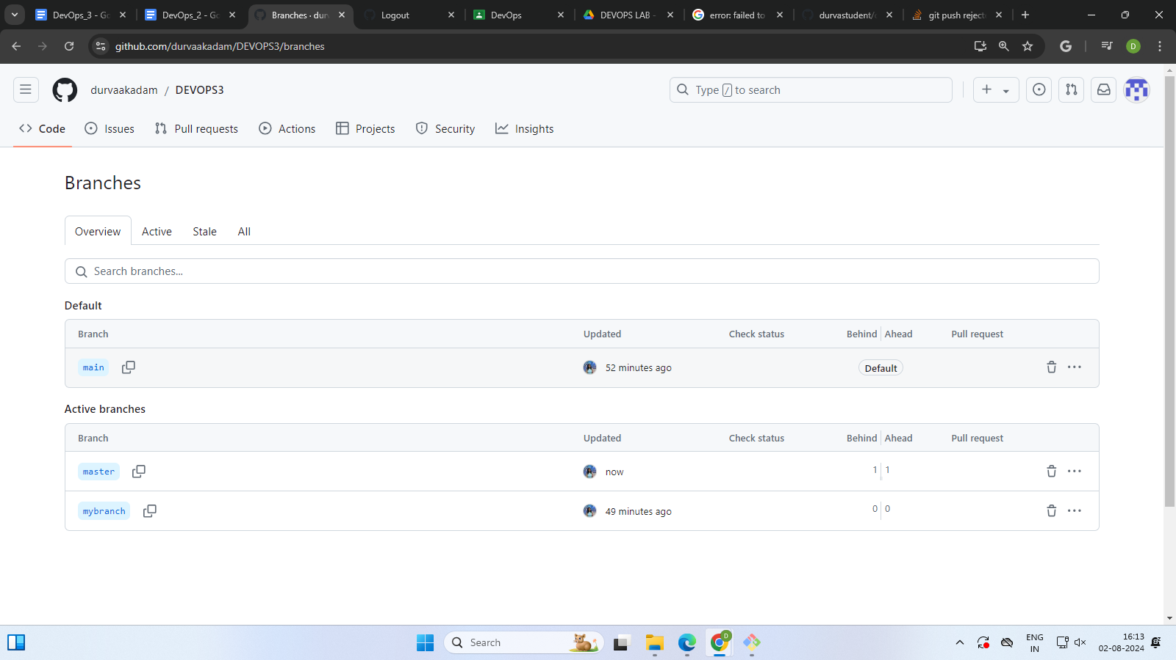

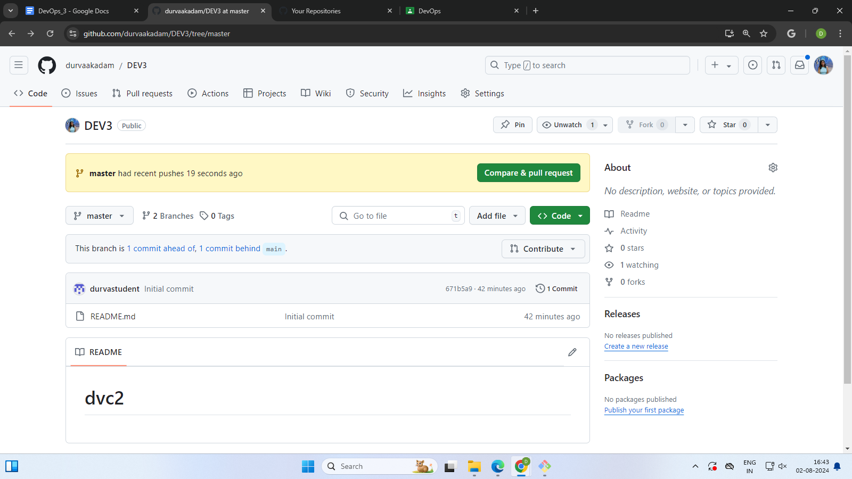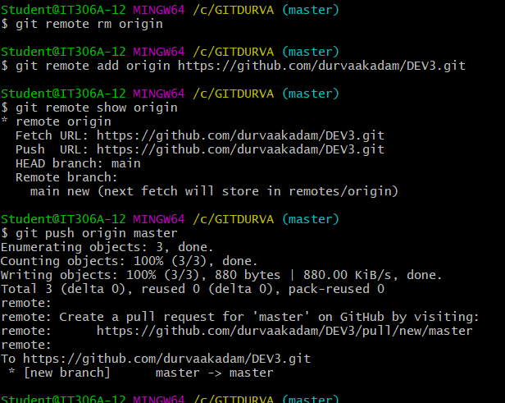

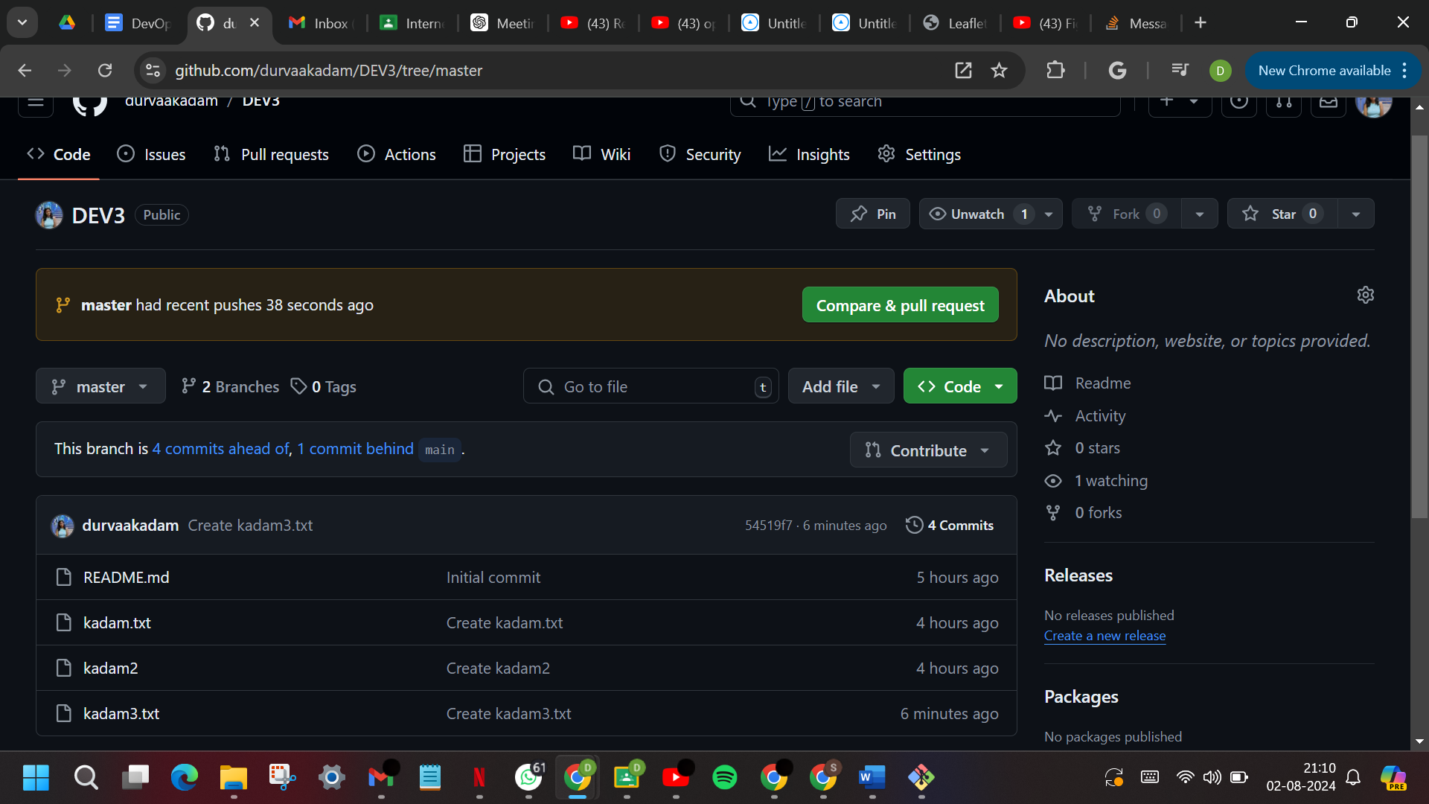

**GIT PULL:**

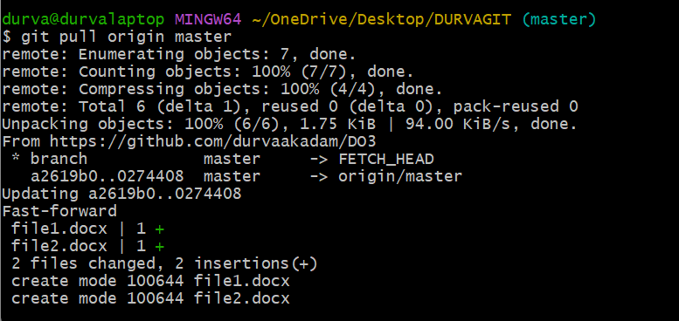

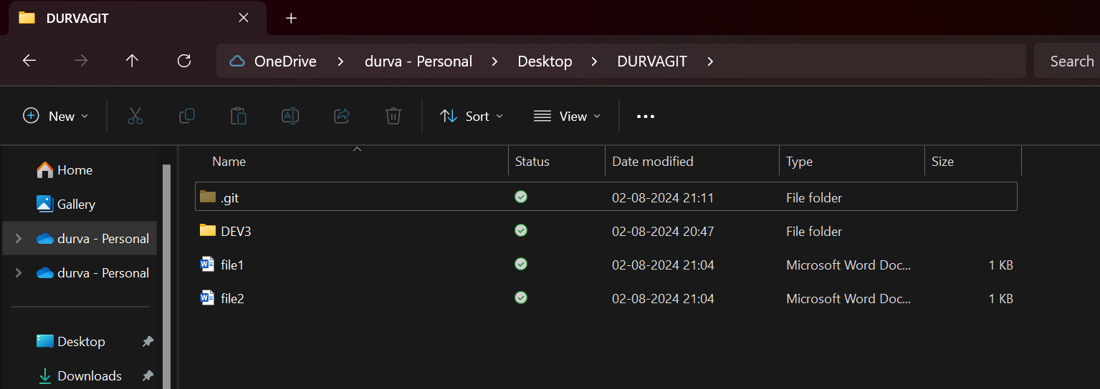

**GIT FETCH, MERGE:**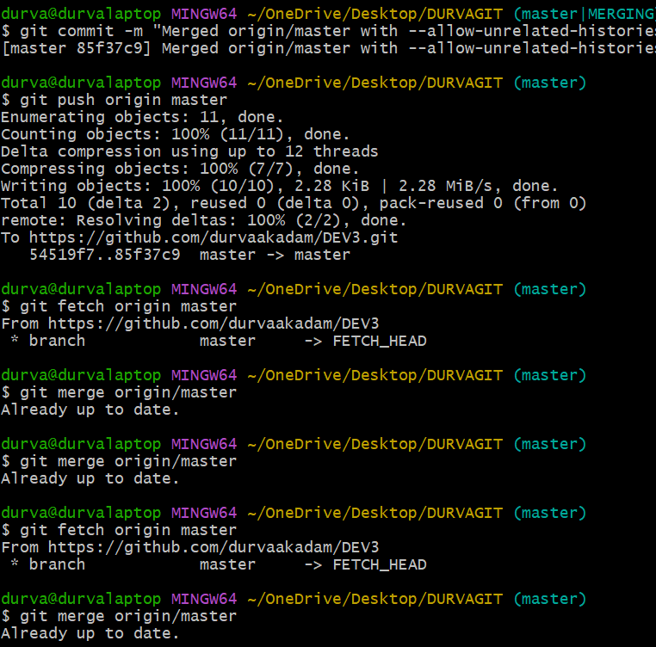



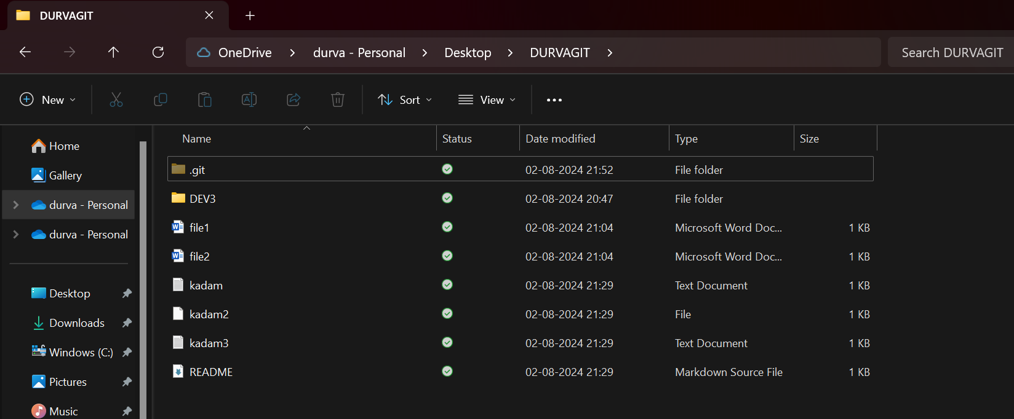

**Git cheat sheet commands:**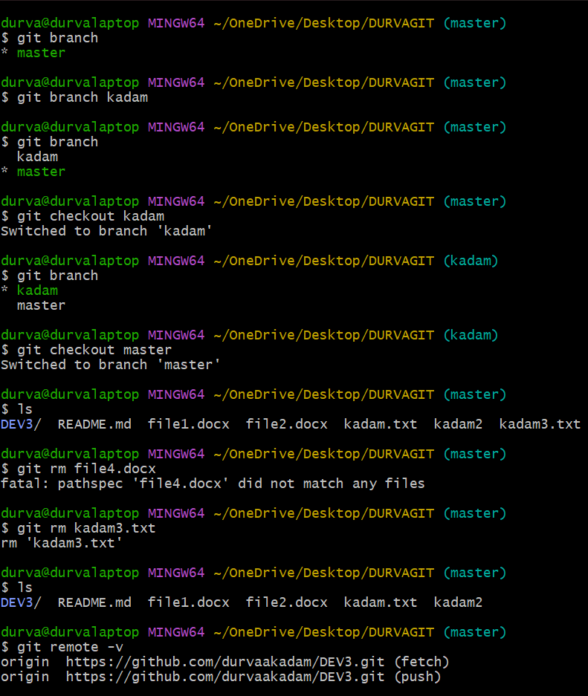



**2 other commands from git cheat sheet:**

